GREENWOOD PUBLIC SCHOOL, ADITYAPURAM
OUR MOTTO - DEVELOPMENT WITH DELIGHT
SYLLABUS FOR THE MONTH OF NOVEMBER(2019-20)
CLASS-NURSERY
SUBJECTS |  |  | ACTIVITY+USE OF ICT | PARENTS INVOLVEMENT
English | Oral:-Rhymes- The Rain on the green grass, Roses are red.  Written:Alphabets – K,L,M,N,O.  Recognition Alphabets- A to L.  Workbook – Page no. 18-21 |  | 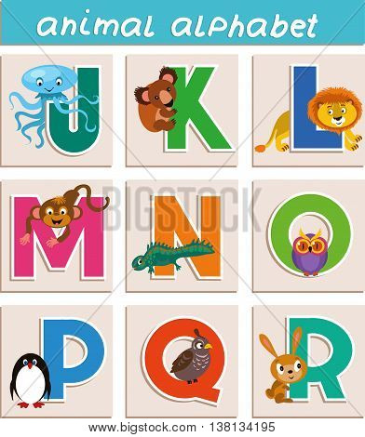 | Help your child in learning rhymes and written work
Hindi | oral- बैंगन बोला, छुक छुक रेल  Written: स्वर अ से औ  Recognition: स्वर अ से औ  Workbook : Page no : 16-21. |  | 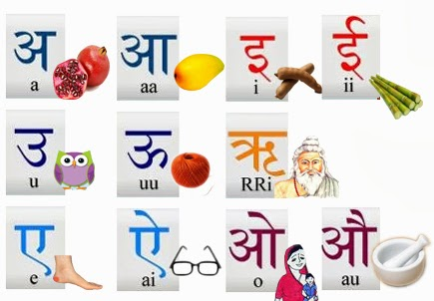 | dfork,sa ;kndjok,WarFkko.kksaZ dh igpkufp=ksa +}kjkdjok,W!
Maths | Oral : Counting 1-30  Written :Digit 8,9,10.  Work book – Page no 17-21.  Recognition Numbers: 1-10. |  | 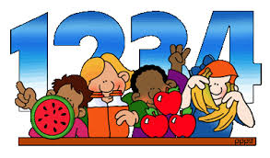 | Motivate your child in counting objects and learning tables.
G.K. Oral | Oral- My family, Wild animals. |  | 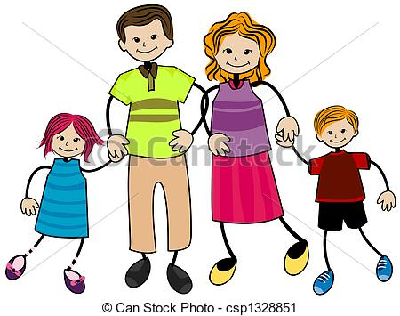 | Visit a park with your child and show different types of flowers
Drawing | Page no 10-14.
V.E. | I love my family. |  |  | Motivate your child to help others
Physical Education | Fun games. |  |  | Take your child for a nature walk.
Language Development | Park, Market, School, Hospital.
Conversation | English Conversation  Q.1 How old are you?  Ans- I am 3 years old.  Q.2 What is your father’s name?  Ans- My father’s name is--------.  Q.3 What is your mother’s name?  Ans- My mother’s name is--------.  Q.4 How many brothers, sisters do you have?  Ans-I have ___brothers ____sisters. |  | Hindi Conversation  प्र1: आप कितने वर्ष के हैं?  उत्तर- मैं तीन वर्ष का/ की हूँ|  प्र2: आपके पिता का क्या नाम है?  उत्तर - मेरे पिता का नाम ______ है  प्र3 आपके माता का क्या नाम है?  उत्तर मेरे माता का नाम ____ है  प्र4 आप कितने भाई और बहन है?  उत्तर: हम ___ भाई और ___ बहन है
 | STARS OF SEPTEMBER MONTH (NURSERY)  1.Vedant Bhargava  2.Jhanvi Bhadouriya  3.Mansi  4.Hridyansh | WILD ANIMALS  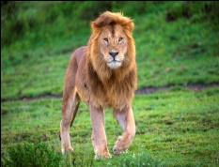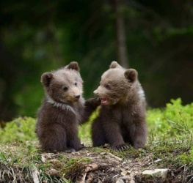  LION BEAR  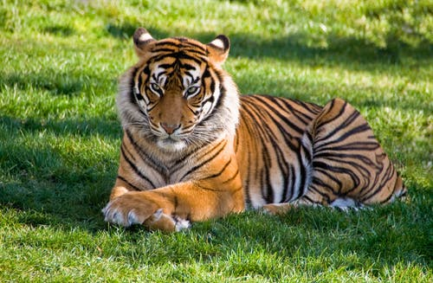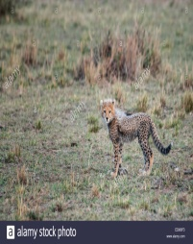  TIGER CHEETAH | THINGS WE SEE IN THE SKY  1.SUN 2.MOON  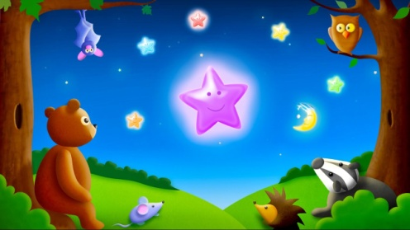3.STARS

